Home Automation using Bluetooth

Registration Number: 21BPS1134

- Aim
The aim of the Home Automation experiment using Bluetooth and HC-05 is to create a system that allows remote control of various electrical devices through a smartphone. By integrating an Arduino Uno, an HC-05 Bluetooth module, and a relay, users can switch devices on or off using a custom app. The project aims to simplify daily tasks and enhance convenience in home automation

- Components

- Arduino board (e.g., Arduino Uno)
- Bluetooth module (HC-05)
- LED lights
- Breadboard
- Jumper wires
- Smartphone with Arduino controller app installed

- Circuit Diagram

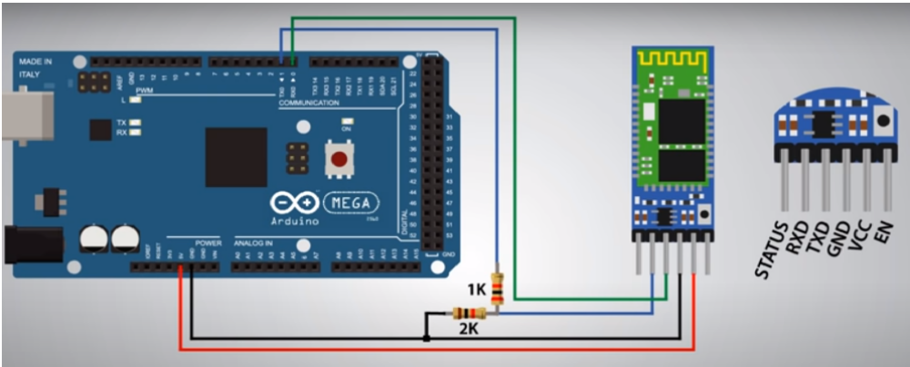
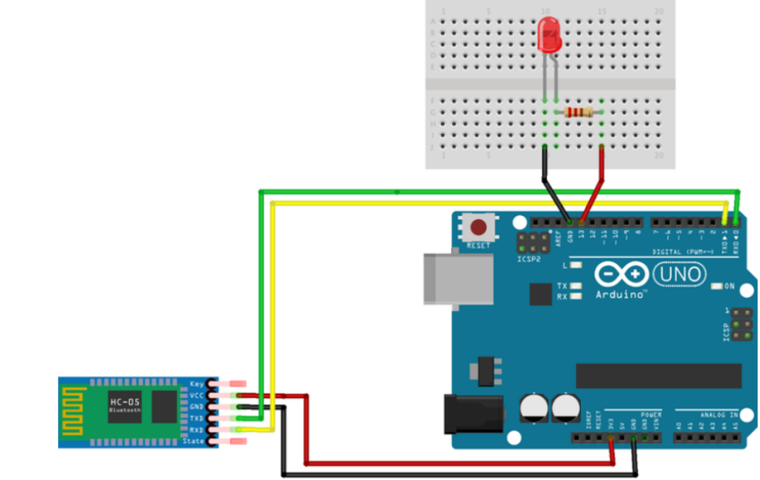

- Procedure

- Connect the Bluetooth module to the Arduino board. Typically, the RX pin of the
- Bluetooth module connects to the TX pin of the Arduino, and vice versa.
- Connect the LED lights to the Arduino board via the breadboard. Connect the anode (longer leg) of each LED to digital pins on the Arduino using jumper wires, and connect the cathode (shorter leg) of each LED to a common ground pin on the Arduino.
- Power the Arduino board using an appropriate power source.
- Install and configure the Arduino controller app on the smartphone.

- Source code

const int LED = 5;
char switchstate;

void setup() {
Serial.begin(9600);
pinMode(LED, OUTPUT);
}

void loop() {
while (Serial.available() > 0) {
switchstate = Serial.read();
Serial.print(switchstate);
Serial.print("\n");
delay(15);
if (switchstate == '1') {
digitalWrite(5, HIGH);
} else if (switchstate == '0') {
digitalWrite(5, LOW);
}
}
}

- Output
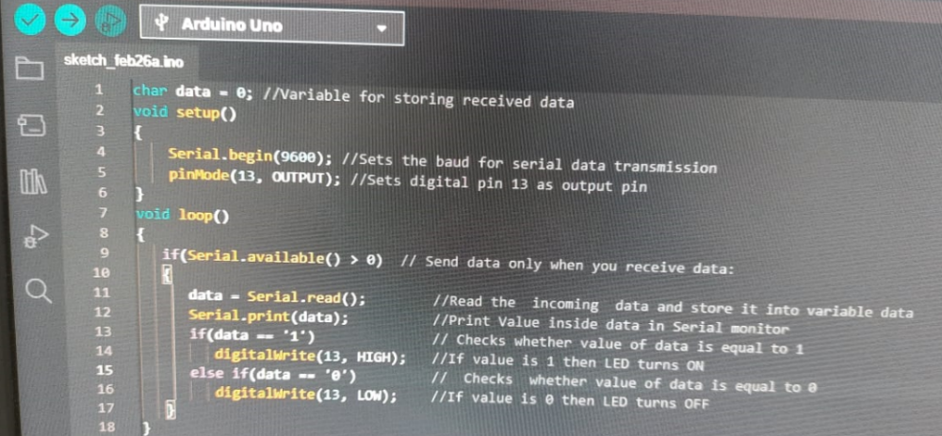

- ON state
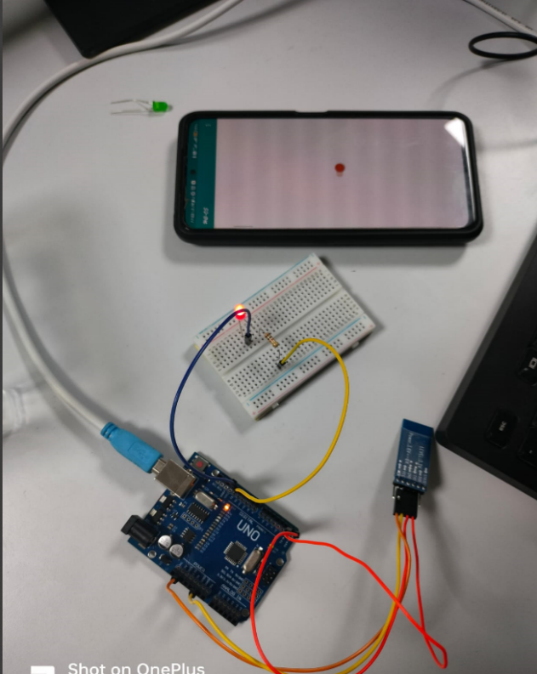

- OFF state
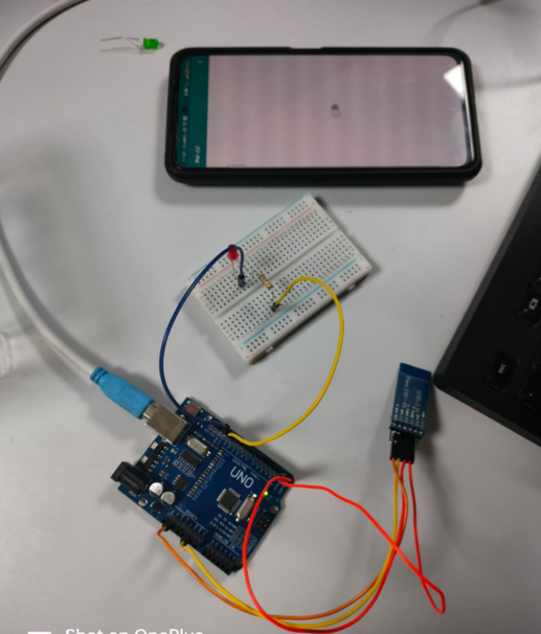

- Inference:
This project demonstrates the implementation of a basic home automation system using Arduino, Bluetooth communication, and LED lights. By utilizing Bluetooth technology, the system offers wireless control of LED lights, enhancing convenience and flexibility for users.
The project serves as a foundation for further customization and expansion of home automation functionalities, such as integrating additional sensors or controlling more complex devices. Overall, the project showcases the potential of combining Arduino-based hardware solutions with smartphone applications to create simple and accessible home automation systems.

- Result:
Users can open the Arduino controller app on their smartphone and establish a Bluetooth connection with the Arduino board. The app presents a user interface with options to control LED lights connected to the Arduino. Users can toggle switches or buttons on the app interface to turn LED lights on or off remotely.
When a command is sent from the app to the Arduino via Bluetooth, the Arduino processes the command and activates or deactivates the corresponding LED. Users can monitor the status of connected LED lights in real-time through the app.

